Mayberry Modernism: North Carolina's Modernist Legacy
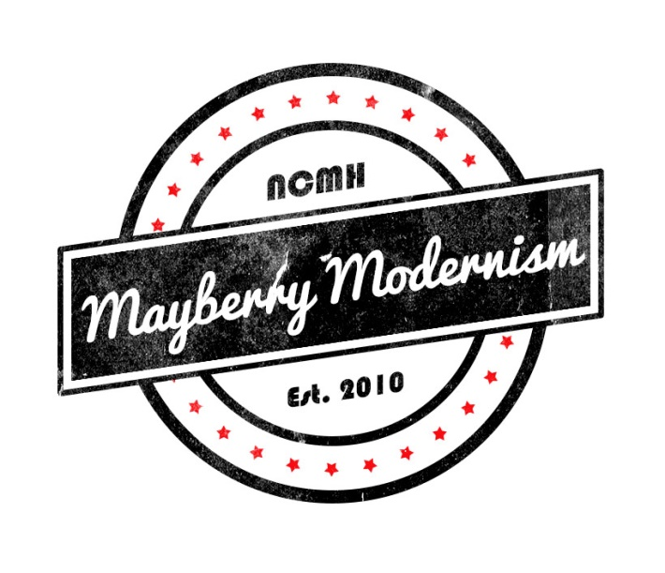
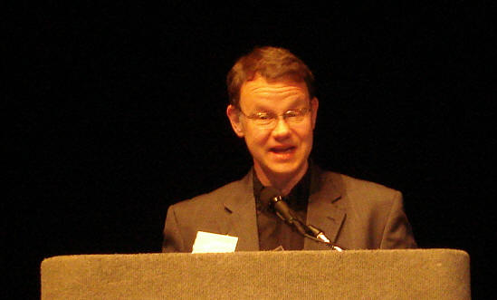
George Smart speaks at 2014 Palm Springs Modernism Week
What's North Carolina's greatest secret? We have the third most Modernist houses in the country. Seriously. Archivist and architectural historian George Smart’s discovery of North Carolina's large number of “livable works of art” in 2007 led him to start North Carolina Modernist houses, the largest open digital archive of Modernist residential architecture and architects in the nation.
During this exciting and visually fascinating 60-minute presentation, you'll visually explore some of the state's Modernist gems, many still glorious, some endangered, and some destroyed forever.
Since 2010, NCMH's founder and Executive Director George Smart has taken Mayberry Modernism on the road to architects, preservation organizations, realtor associations, senior centers, and other fans across the state. Mayberry Modernism includes time for questions, plus George will stay afterwards to talk with your audience.
About George Smart
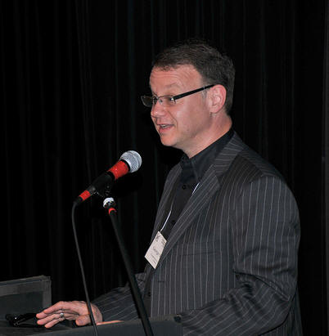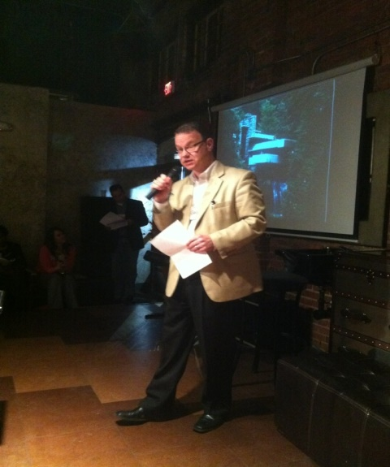
George Smart grew up in Triangle architecture. His dad was a Raleigh architect for over 40 years who, like many in his generation, was inspired by the exciting designs of Frank Lloyd Wright and the Modernist movement. George's mom Ann Seltman Smart was a radio personality on WPTF and made a documentary on architecture in the 1960's that's still available on YouTube.
Yet, as a management consultant and executive coach, George showed no interest whatsoever in architecture until 2007. "I was Googling for modern houses one night and it was like that scene from Alien," jokes Smart. "Something very powerful exploded from my DNA! One search led to another, then to a list, then to a website, then to tours, then trips, then dinners, then movies, then design community networking happy hours. NCMH is now the largest open digital archive in America for residential Modernist architecture."
George Smart and NCMH have been honored with many historic preservation awards for accomplishment at the local, state, and national level.
North Carolina's most passionate advocate for Modernist architecture, George Smart facilitates the public's discovery of these "livable sculptures" through presentations around the state. His knowledge of North Carolina modernism combined with the innovative use of technology for preservation has quickly established a national reputation for research and advocacy. He was the Raleigh News and Observer Tar Heel of the Week, June 2012.
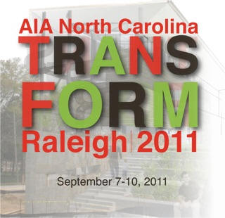
"George Smart's Mayberry Modernism presentation is entertaining, informative, and inspiring. When the hour is over you are left wanting to know more." -- Mark Allison, AIA
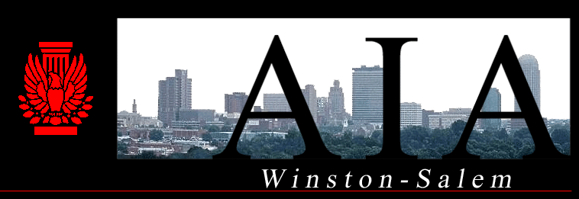
"Thank you so much for your exciting presentation to the Winston-Salem Section of the AIA. I got a lot of great comments from several people afterwards and it was one of the most well attended luncheons ever."
-- Chad Everhart, AIA, NCARB
"I do want to thank you for making the trip to Wilmington and speaking to AIA Wilmington and the Cameron Art Museum. We were pleasantly surprised at the large turnout that we had at the event, especially for a Monday night. Everyone with whom I spoke afterwards said that they were impressed with your knowledge of modern architecture and really enjoyed all of the images that you presented. I hope that you can bring this lecture to all of the AIA sections in North Carolina!" -- Laura Miller, AIA, LEED AP
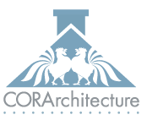
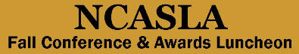
"George Smart gives a fascinating and informative slideshow and presentation about some of our true architectural treasures - the wealth of Modernist homes in our area." -- Mark Zimmerman, Chapel Hill Realtor
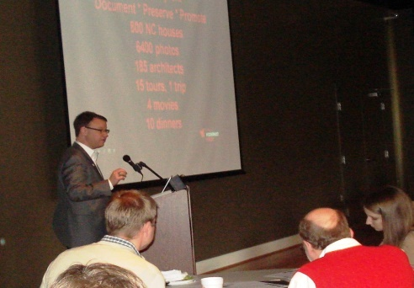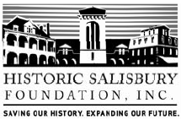
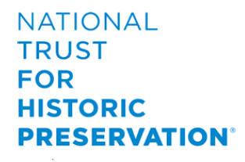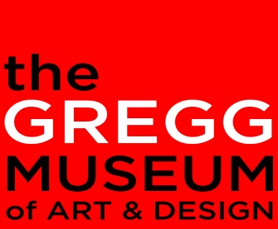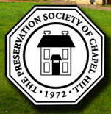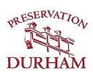
Chapel Hill Rotary Club
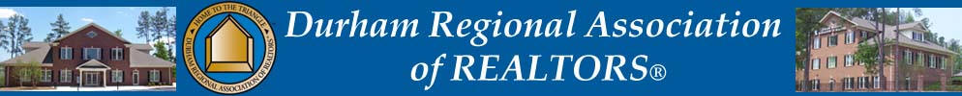
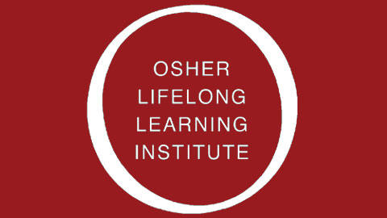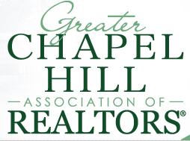
Cameron Village Library, Raleigh (twice)
North Raleigh Regional Library, Raleigh (twice)
West Regional Library, Cary
South Durham Regional Library, Durham
Chatham County Library, Pittsboro
Durham Central Library, Durham
Lappas and Havener Landscape Architects, Durham
Durham Engineers Club, Durham
Carolina Country Club, Raleigh
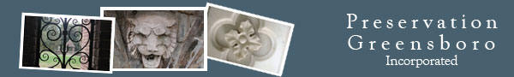
Preservation Society of Chapel Hill
YSU/Prudential, Durham
Raleigh Kiwanis, Durham
Tobaccoland Kiwanis, Durham
City of Raleigh Museum, Raleigh
Southwest Durham Rotary Club, Durham
Hope Valley Rotary, Durham
The Garage, Winston-Salem
Hickory Preservation
City of Raleigh Past Employees
Leadership Triangle
Carol Woods Retirement Center
Carolina Meadows Retirement Center
Emerald Pond Retirement Center
First Baptist Church
Cedars Retirement Center
NCSU College of Design (several times)
Junior League of Durham and Orange Counties
Learning Objectives (for continuing education audiences)
Participants learn how thousands of significant Modernist houses were documented and made available to the public online.
Participants identify the beginnings of North Carolina residential Modernist design as part of a national movement.
Participants learn key differences between Modernist and contemporary architecture.
Participants learn why North Carolina is the third largest concentration of Modernist houses in the country.
Participants learn the key architects and influencers in North Carolina Modernism.
Participants gain knowledge of 60 years of North Carolina award-winning residences and assess their own preferences against precedent.
Participants learn marketing methods to preserve mid-century Modernist houses through preservation, occupancy, and sustainable development strategies.
Participants discover how documenting, preserving, and promoting residential Modernist design benefits the architecture and construction industries.
Participants learn key differences between selling a traditional house and selling a Modernist house.
Participant gain free access to a digital archive of over 22,000 photos of over 6,500 Modernist houses, along with profiles on 300+ architects.
Participants learn how NCMH became the country's largest open digital archive for Modernist houses and a recognized leader in Modernist preservation with 12 local, state, and national awards.

